Import Data using Transform Maps (Spreadsheet)
Milestone 4 : Creation Of reports & dashboards
Activity 8: Report 1
Create Reports on Employee Test Table
Navigation Steps :
1.Open All menus, Search for Reports.
2.Under Usage and governance Select Reports.
3.Click the New button to create a new report.
4.Create 3 Reports as follows.

Report 1: Employees by Department
1.In Data
2.Report name : Employees by Department.
3.Source Type : Table.
4.Table : Employee Test, Now click the Next button.

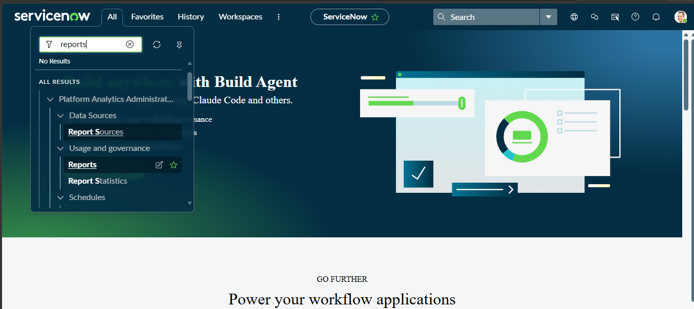
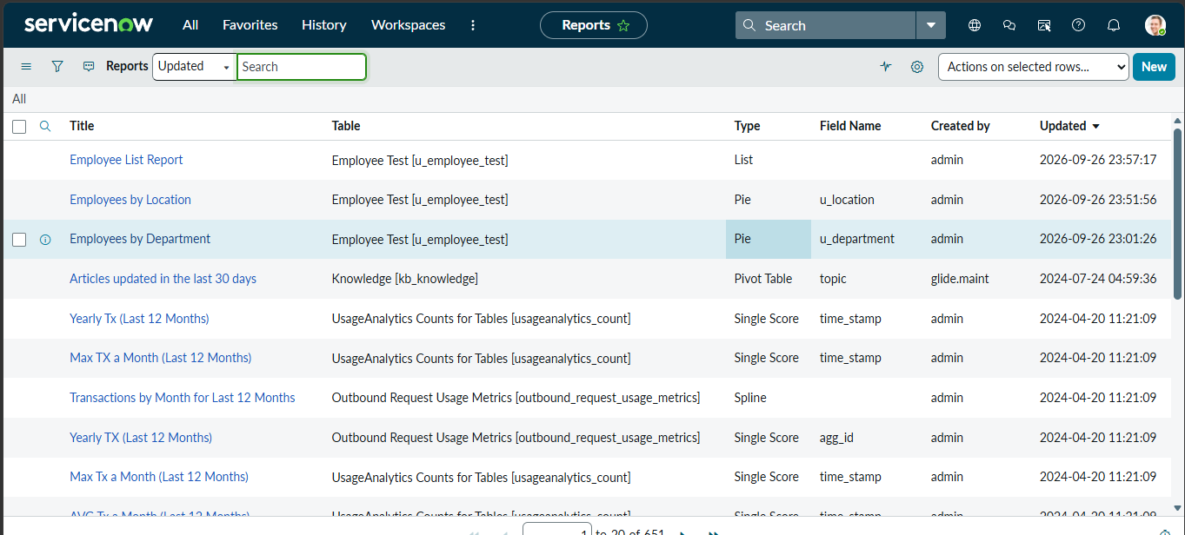

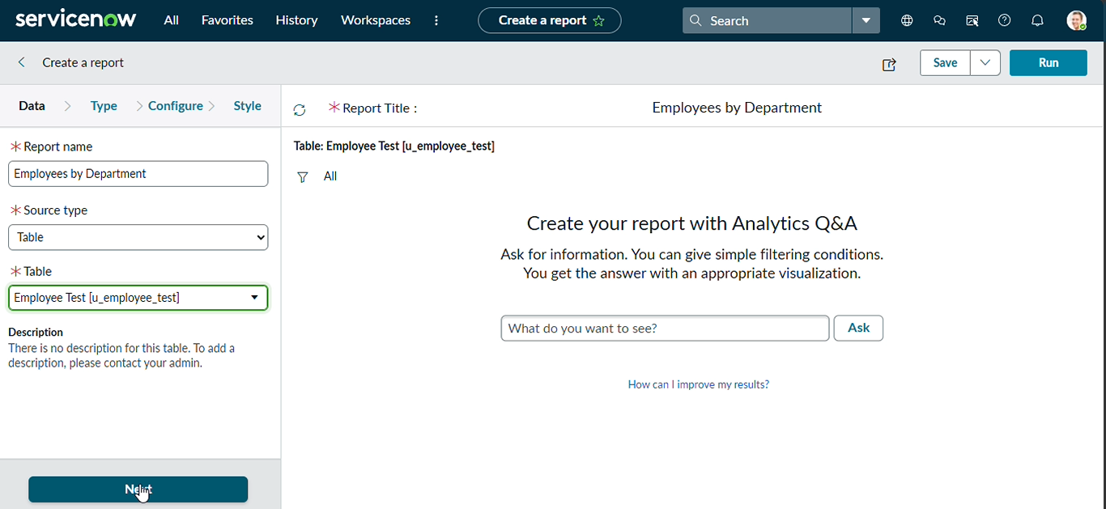

5.Now after Clicking next in type Select Pie chart .
6.And click the next button

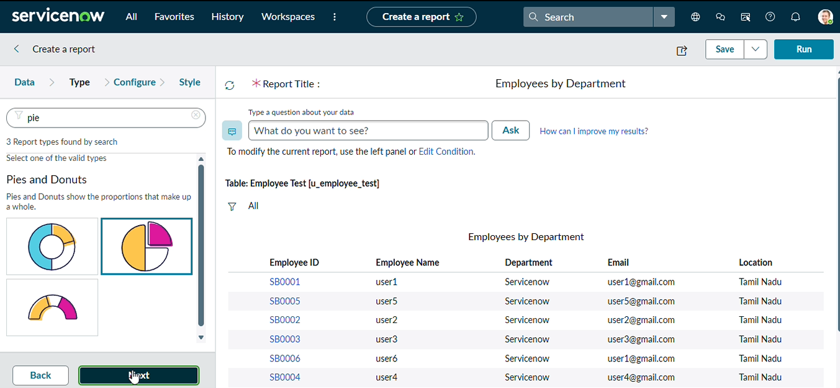
7.Now In Configure Select Group by Department Field.
8.In the Aggregation Field Select Count.
9.Then Click next.

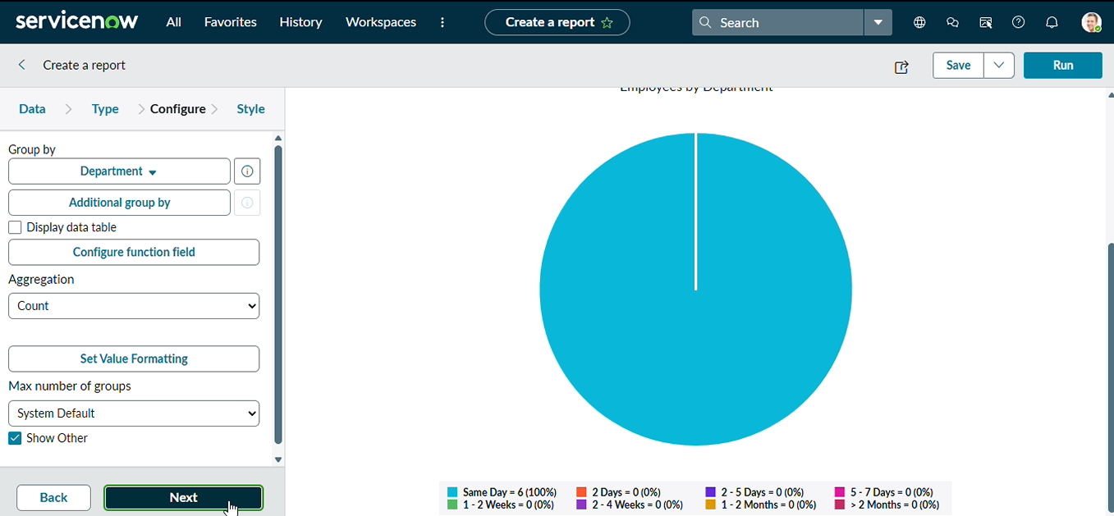

10.Now In Style Leave the Chart color by default.
11.And Click the Run button to Execute the given data Report.
12.And Click save button to Save the Report.

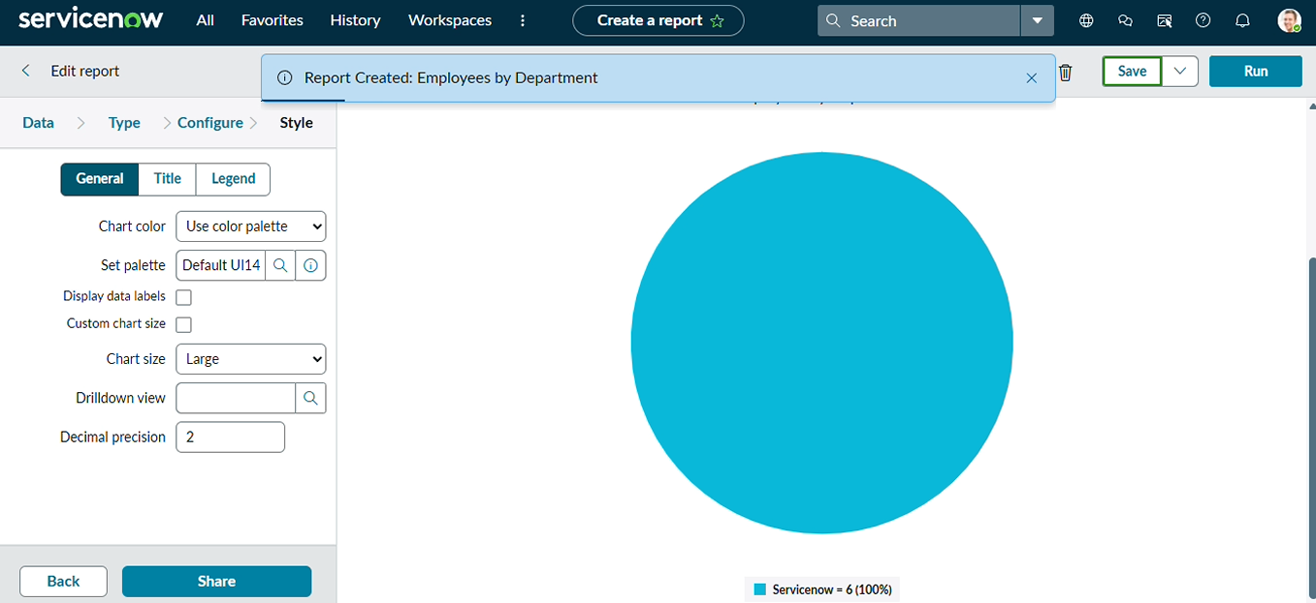

Activity 9 : Adding Reports to Dashboard
Create Dashboard
Navigation :
1.Open All menus → Search for Dashboards.
2.Under Self Service → Click Dashboards.
3.On the top right corner Click Create Dashboards or
4.You can create Directly by using the backend name[ PA_DASHBOARDS.FORM ].
5.Then Click New to Create new Dashboards.
6.Only the backend name will open the form if the ACL has the pa_dashboards access to Admin Overrides True only.
7.Then only we have access to the form

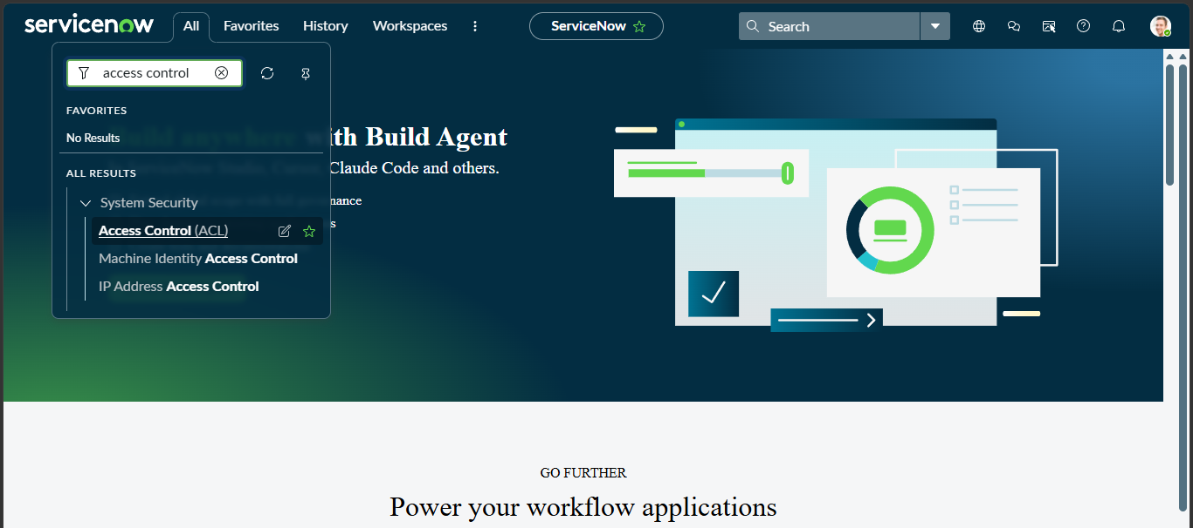
8.After Opening the ACL Search the pa_dashboards on Name Column

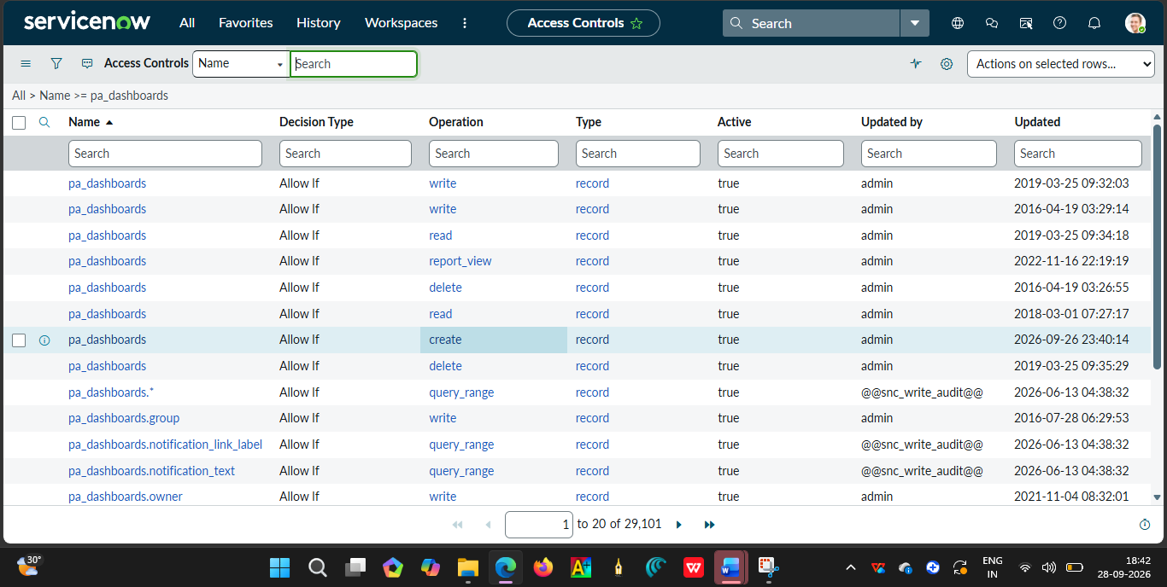
9.Now Open the Create Operation row

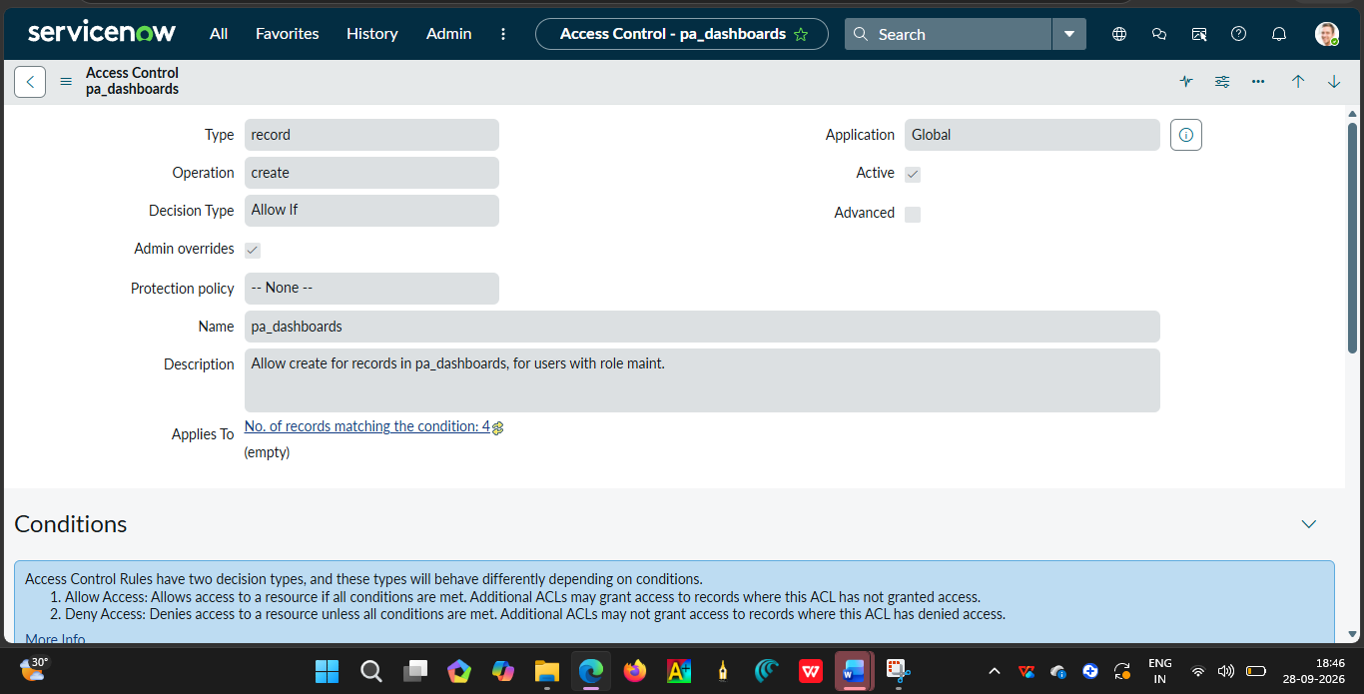
10.Then Click Enable the True for Admin Overrides and Update the Form.
11.Then the creation of dashboards will be possible by using the backend name.
12.Now Open the PA_DASHBOARDS.FORM create dashboard.
13.Dashboard name : Employee Analytics Dashboards.
14.Save the Form.

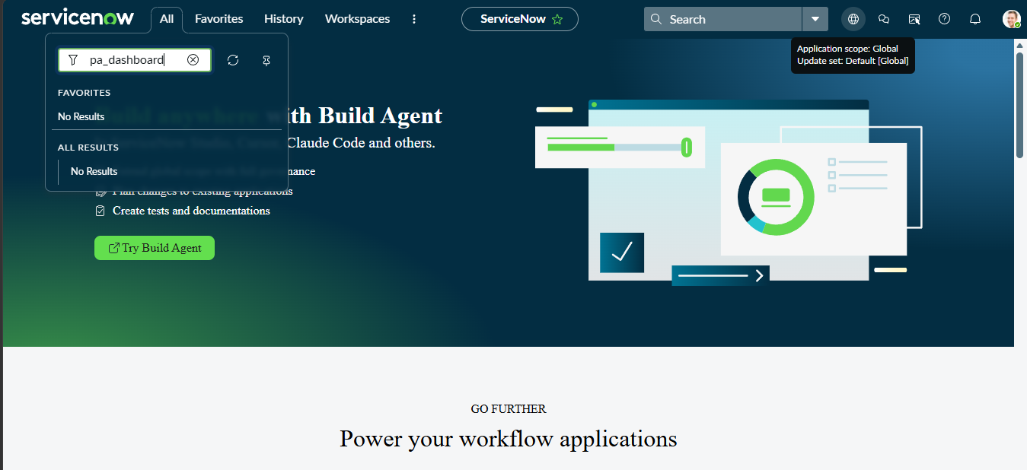

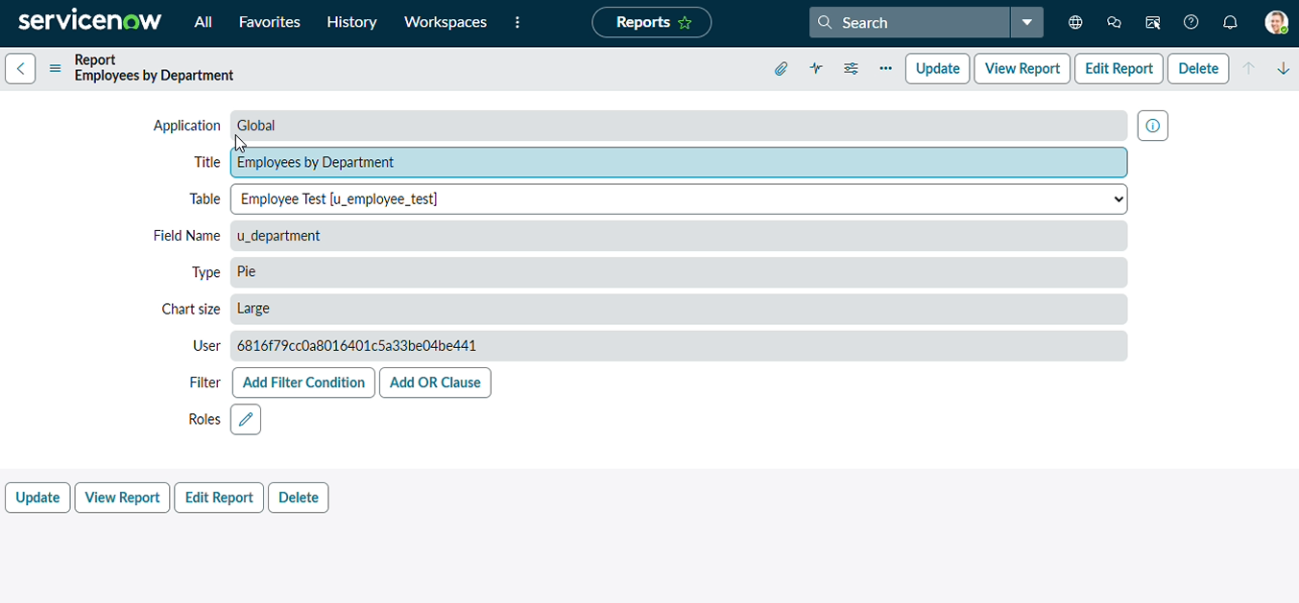
Add Reports to Dashboards.
Navigation Steps:
- Open the Previously Created Reports.
- On All menus → type Reports Under Usage and Governance select reports.
- Open the Employees by Department.
- Select the Edit Report and Click the Share button then the right top corner Select the Add to Dashboards Option.
- Then Choose the Created dashboard name and Click Add button
- Same Like that do the remaining 2 reports in the same navigation how we added Employees by Department.
- The Employees by Location and Employee List Report these two reports are also added to the created dashboard.

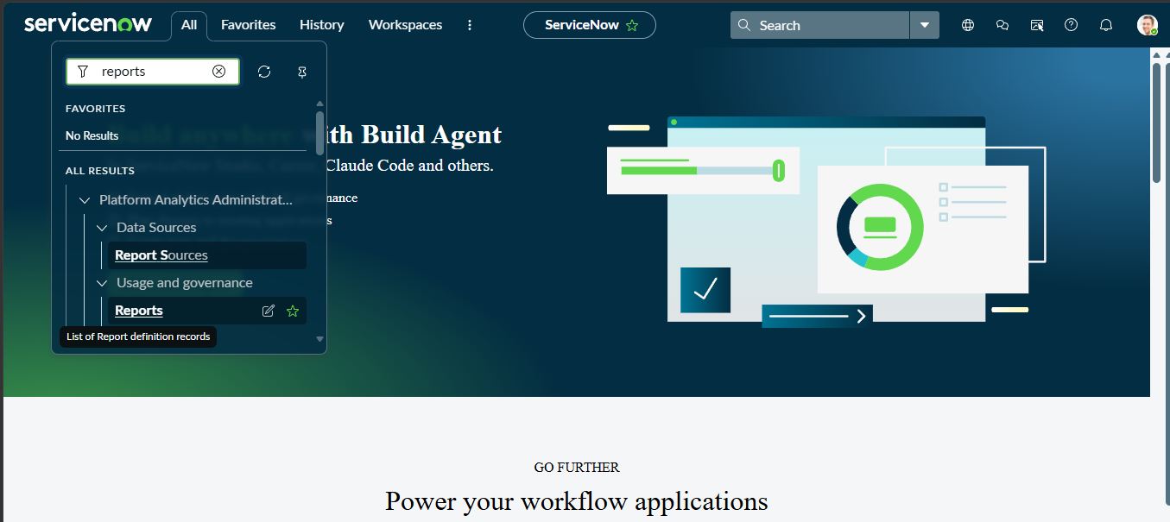
- After Opening the Report Click the View Report Button on the right side of the Context menu.

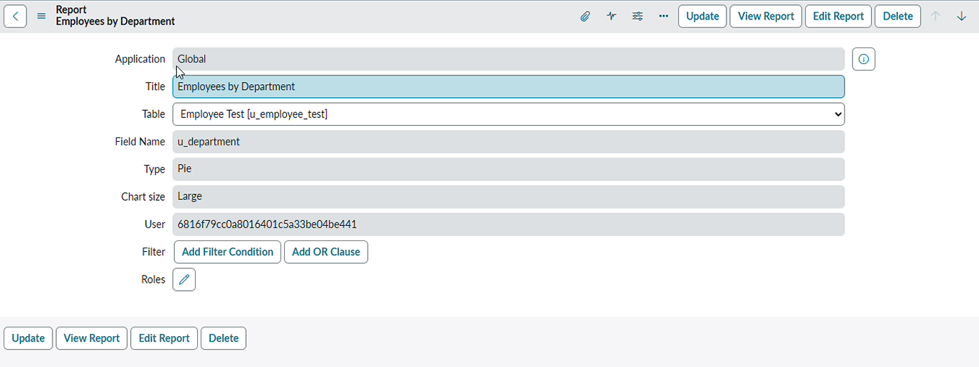
- After Clicking the View Report button, Now Click the Share button and then share options are visible on the right side.
- Now click the Add to Dashboards

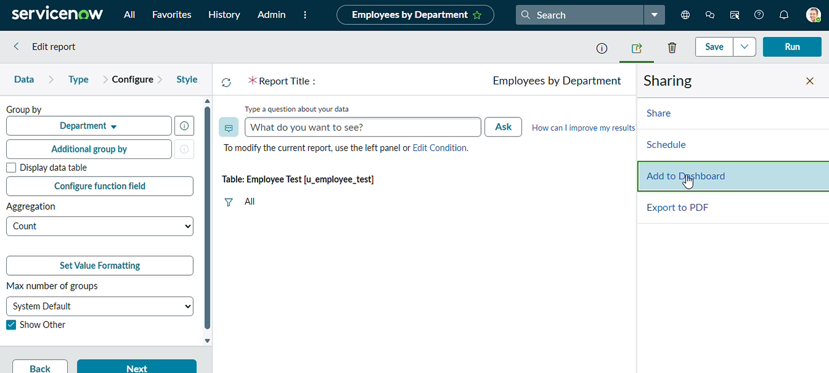

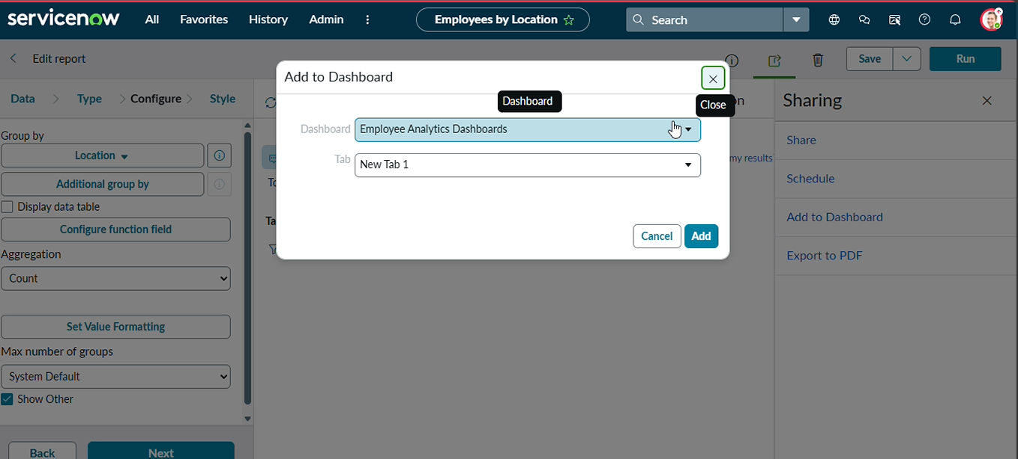
- Now Add the Dashboard that you created called Employee Analytics Dashboards.
- Then Click Add button.
- Now the Report is added to the dashboards.
- Now, Same in the process, add the remaining two reports to the dashboard.
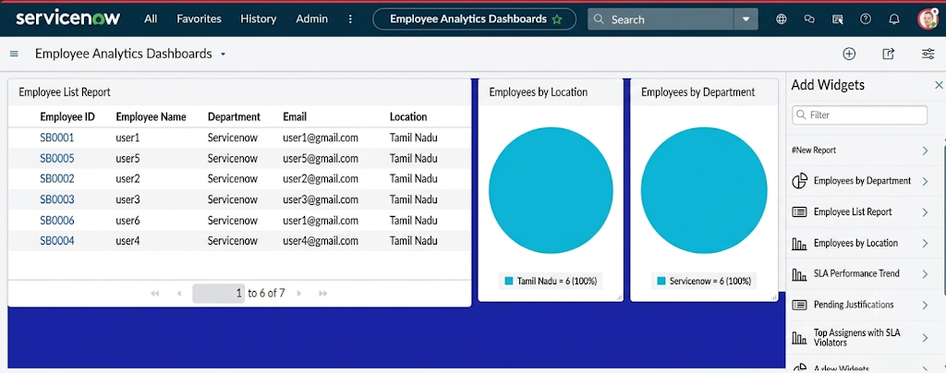
Here the three Reports are added successfully by varying Department , Location and List Report.
We can also restrict the Users,Groups and Roles From Share Option.

Conclusion:
1.This project successfully implemented an automated employee data management solution using ServiceNow Import Sets and Transform Maps, ensuring accuracy, efficiency, and data integrity throughout the employee onboarding and update process.
2.A key enhancement in this project was the use of Coalesce in the Transform Map. By enabling Coalesce on the Employee ID field, the system intelligently identifies existing employee records during every import. This prevents the creation of duplicate records and ensures that repeated imports update existing data instead of inserting redundant entries. As a result, the employee database remains clean, reliable, and consistent, which is critical in real-world enterprise environments where data may be imported multiple times from external systems.
3.In addition to data integrity, the project was extended with Reports and Dashboards to provide meaningful insights and real-time visibility into employee data and import activities. Custom reports were created to track:
- Total employee records.
- Newly added employees.
- Updated employee records.
- Department-wise employee distribution.
- Import success and error counts.
4.These reports were then consolidated into a Dashboard, allowing administrators and HR teams to monitor employee data trends, import performance, and data quality from a single centralized view. Dashboards improved decision-making by presenting information visually through charts and graphs, reducing the need for manual analysis.

